Space Complexity in Modern Systems: Challenges and Solutions

Introduction
In computer science, examining the efficiency of algorithms usually centers around two main factors: time complexity and space complexity. Time complexity measures how long an algorithm takes to run based on the size of its input . while we have this has often been the main concern,the raoid increase of digital data in mordern systems has highlighted the importance of space complexity. The massive growth of data from sources like server logs, IoT devices, transactional systems, and user-generated content creates challenges for system performance, storage, and long-term scaling. This literature review looks at key strategies and methods for managing and reducing space complexity, drawing on established practices in data management and system design.

Literature Review

Data Retention and Deletion Policies
A key strategy for controlling data growth is to implement strong data retention and deletion policies. These policies create a clear framework for deciding how long to store data based on its business, legal, and compliance value. Data that is no longer useful can be safely deleted, freeing up important storage space. This proactive measure helps prevent the buildup of outdated data, which can consume space and complicate data governance, increasing the risk of security breaches.This effective policies need regulatory requirements like GDPR and HIPAA,throwing a balance between data availabilty and storage efficiency.

Log Rotation and Pruning

For systems that produce large amounts of log data, like web servers and distributed applications, log rotation and pruning are vital techniques. Log rotation automatically archives or deletes older log files at set intervals (daily or weekly) once they reach a specific size or age. This keeps any single log file from growing too large, which could use up disk space and slow down system performance. Pruning means taking out unnecessary information from logs while keeping important records for troubleshooting and analysis. These techniques are important for maintaining system stability. They help make sure that log data stays manageable and useful, even with its large volume.

Data Deduplication
Data deduplication effectively reduces storage costs by removing duplicate copies of data.A single distinct version of the data should remain while all other duplicates must reference the original version. The method proves particularly beneficial when multiple instances of identical data exist within backup systems or virtual machine environments or large databases. The process of deduplication enables significant storage space reduction by combining identical files or blocks which can reach up to 90% reduction in particular use cases.This process needs a method to hash and index data blocks to find duplicates quickly. While it adds some computational work, it offers significant long-term storage benefits.

Compression and Archiving

Two efficient methods for computer space management are compression and archiving.By more effectively encoding information, data compression algorithms such as gzip and zlib minimize file sizes and the amount of storage required. The advantages of less storage usage are frequently significant, even though compression does require more CPU power for encoding and decoding.

Real-time Data aggregation
This approach condenses the data as it is received into important metrics, trends, or statistical summaries rather than retaining all of the raw data points.Instead of storing each individual reading, a system might, for instance, store the average temperature or humidity for each hour or day. This significantly lowers the volume of data that must be kept on file for an extended period of time. It also makes the system more scalable and efficient. While this technique can result in a loss of detail, it is a practical solution for situations where detailed history is not necessary. A single distinct version of the data should remain while all other duplicates must reference the original version. The method proves particularly beneficial when multiple instances of identical data exist within backup systems or virtual machine environments or large databases. The process of deduplication enables significant storage space reduction by combining identical files or blocks which can reach up to 90% reduction in particular use cases.

Proposed Solution
A hybrid approach combining deduplication, compression, and summarization is proposed. This method ensures that redundant and unnecessary data is removed, essential data is compressed, and large data streams are summarized in real-time to prevent uncontrolled growth.

Sample Python Implementation output :

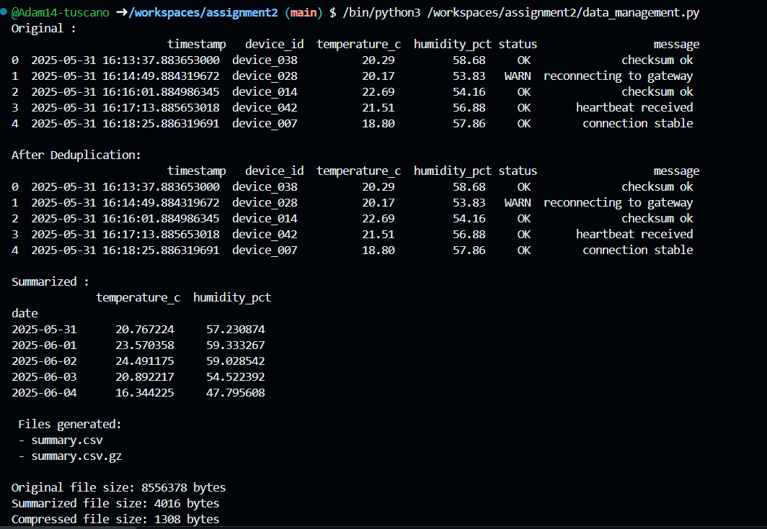

Synthesis
Overall, the literature shows that no single strategy works on its own. Instead,Successful space complexity management relies on combined solutions that integrste policies,deduplication,compression and summarization.new approaches promote easy frameworks that can adapt techniques based on workload patterns,data importance and system limits.

